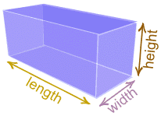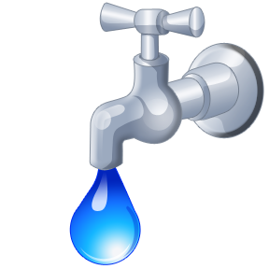

GRADE

th

5

**In 5th grade students will gain important new skills while continuing to build on last year’s work.  
  
 (1) Extend their work with**

**addition, subtraction, multiplication**

**and division with whole numbers.**

**(2) Apply these concepts as they work with decimals and fractions.**

**(3) Use multiplication and addition skills to find geometric measurements including volume.**

**Fifth grade is a milestone and a pivot point for students as they prepare for ratio and proportional thinking in later grades.**

**STANDARDS FOR MATHEMATICAL PRACTICE**

**The following practices allow students to become successful in learning mathematics.**

**WHEN WORKING A MATH PROBLEM…**

1. Look for ways to solve problems, make a plan, and discuss how I solved them. I listen to different strategies and use another method to check my answer. I ask myself “Does this make sense?”
2. Understand that numbers represent quantities (how many) and can be written with symbols to represent addition and subtraction.
3. Explain my thinking and the thinking of others using objects, drawings, and mathematical words. I ask questions like “How did you get that?” and “Why is that true?”
4. Show different ways to solve a problem and I check my answer to see if it makes sense.
5. Consider available tools, including estimation, to solve a problem and decide which are most helpful?
6. Solve problems accurately and efficiently and use mathematical vocabulary to explain my thinking.
7. Discover patterns and rules as I work with whole numbers and fractions.
8. Recognize patterns in numbers and these patterns help me take short cuts, I continually check my work by asking “Does this make sense?”

**HOW TO HELP YOUR CHILD AT HOME**

* Look for “word problems” in real life. Some 5th grade examples might include:
* Determine the number of 1½ cup servings there are in a 2 pound bag of sugar.
* Help balance a checkbook by doing calculations with decimals.
* Using the length, width, and depth of a garden plot to determine how many bags of garden soil to buy.
* Multiplying with fractions — for example, if you used about 2/3 of a 3/4-cup measure of vegetable stock, then how much stock did you use? About how much is left?
* Look for patterns with numbers. For example from a graph in the local newspaper.
* Practice working with decimals to the thousandths.
* Practice adding, subtracting, multiplying and dividing fractions.
* Find the volume of different rectangular 3-D objects around the house.
* Play “Name the Equivalent Fraction.” For example, ask your child to name a fraction equivalent to 2/3.
* Compare fractions by finding common numerators or common denominators or by comparing them to benchmark numbers such as 1/2.

 

**THE COMMON CORE**

**STATE STANDARDS FOR**

**MATHEMATICS**

***www.webaddress.com***

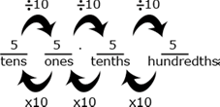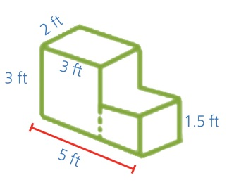

**2 cups**

**NUMBER AND OPERATIONS-FRACTIONS**

**Fifth grade students extend the fraction work to addition and subtraction of fractions with unlike denominators and mixed numbers. Students work with area models to understand multiplication and division of fractions.**

**EXAMPLES:  
 I can solve problems like these:**

* + Sonia had 2 1/3 candy bars. She promised her brother that she would give him ½ of a candy bar. How much will she have left after she gives her brother the amount she promised?
  + Steve’s lawn is 1 ¾ acres. His neighbor’s lawn is ½ the size of his lawn. How many acres is his neighbor’s lawn?
* I can solve real world problems involving division of fractions using a model.  
  + How many 1/3 cup servings are in 2 cups of raisins?

**MEASUREMENT AND DATA**

**Fifth grade students should be able to make line plots and analyze the data. They will also be able to measure volume of objects using multiplication.**

**EXAMPLES:**

* I can convert measurements to solve multi-step, real world problems.
* I can add, subtract, multiply or divide fractions to solve problems with information presented in line plots.

**GEOMETRY**

Fifth grade students graph points, interpret the data and sort two-dimensional figures in categories based on their properties.

EXAMPLES:

* I can interpret coordinate values of points in the context of real world and mathematical problems
  + Use the graph below to determine how much money Jack makes after working exactly 9 hours.
* I can use attributes of 2 dimensional figures to determine into which category they belong.  
  For example:
  + All rectangles have four right angles and squares are rectangles, so all squares have four right angles.

**NUMBER AND OPERATIONS**

**IN BASE TEN**

Fifth grade students extend the number system to decimals and learn to use them in basic operations of addition, subtraction, multiplication and division. They become fluent with multi-digit multiplication and begin to learn division strategies.  
  
EXAMPLES:

* I can explain the patterns in multiplying by 10, 100, 1000, etc. by the number of zeros in the product.
* I can explain the placement of the decimal point when a decimal is multiplied or divided by a power of 10.

**OPERATIONS AND ALGEBRAIC THINKING**

**Fifth grade students begin to use parentheses to write and solve equations in preparation for middle school mathematics. They extend their work to look at a relationship between two patterns preparing a foundation for algebra.**

**EXAMPLES:**

* I can use parentheses, brackets, or braces to show my understanding of the order of operations.   
  + *(26 + 18) $÷$ 4=11*
  + *{[2 x (3+5)] – 9} + [5 x (23-18)]=32*
* I can identify a relationship between two numerical patterns.

(17+33) 5=10

* I can solve real world and mathematical problems involving volume.   
  + Determine the volume of concrete needed to build the steps in the diagram below.

**EARNINGS (in dollars)**

**HOURS WORKED**

|  |  |  |  |  |  |
| --- | --- | --- | --- | --- | --- |
|  |  |  |  |  |  |
|  |  |  |  |  |  |
|  |  |  |  |  |  |
|  |  |  |  |  |  |
|  |  |  |  |  |  |
|  |  |  |  |  |  |

0

2

4

6

8

10

12

4

8

12

16

20